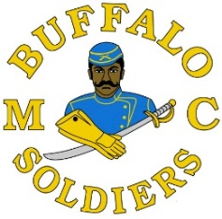

Delaware High School Senior,
Thank you for applying for the Buffalo Soldiers MC of Delaware Scholarship.
The objective of the Buffalo Soldiers is to educate those that are unfamiliar with the racism, sacrifices and hardships that the Buffalo Soldiers of the 9th and 10th Calvaries had to endure. Our vision is to instill this knowledge into the minds and hearts of our youth of today, so that we can motivate them to become better citizens and leaders of tomorrow. We feel by doing this, the legacy of the Buffalo Soldiers of the past will live forever and shall not be forgotten.
We are contributors in our local communities and throughout the state of Delaware by supporting charitable needs and educating others, especially our youth. Our efforts are in large a result of the sacrifices that were made by not only the Buffalo Soldiers, but other African and Native Americans during the pre- and post-civil war periods.
Each year, the Buffalo Soldiers MC of Delaware presents scholarships to deserving high school seniors in Delaware. The winners are selected from a large group of applicants and it is important you read the requirements when submitting your application.
When applying for this scholarship please remember to submit all required documents with your application or your application cannot be considered.
THE FOLLOWING DOCUMENTS MUST ACCOMPANY THIS APPLICATION:
- Letter(s) of Acceptance to an accredited college/university
- Latest official school transcript
- SAT scores
- Three (3) written Letters of Recommendation
- Community Service
- School and/or Outside Club(s) and Activities
- Biographical Sketch/Essay of your life including any unusual family circumstances or information which you feel would help our committee with their decision
  - This sketch should be a minimum of one typed page and a maximum of two typed pages
Sincerely,
The Buffalo Soldiers MC of Delaware Scholarship Committee

